

<Name-of-Software-Application>

# **CS 230 Project Software Design Template**

Version 1.0

## Table of Contents

**CS 230 Project Software Design Template**1

**Table of Contents**2

**Document Revision History**2

**Executive Summary**3

**Design Constraints**3

**System Architecture View**3

**Domain Model**3

**Evaluation**3

**Recommendations**5

## Document Revision History

| Version | Date | Author | Comments |
| --- | --- | --- | --- |
| 1.0 | <mm/dd/yy> | <Your-Name> | <Brief description of changes in this revision> |

**Instructions**

Fill in all bracketed information on page one (the cover page), in the Document Revision History table, and below each header. Under each header, remove the bracketed prompt and write your own paragraph response covering the indicated information.

## Executive Summary

<Write a summary to introduce the software design problem and present a solution. Be sure to provide the client with any critical information they must know in order to proceed with the process you are proposing.>

## Design Constraints

<Identify the design constraints for developing the game application in a web-based distributed environment and explain the implications of the design constraints on application development.>

## System Architecture View

Please note: There is nothing required here for these projects, but this section serves as a reminder that describing the system and subsystem architecture present in the application, including physical components or tiers, may be required for other projects. A logical topology of the communication and storage aspects is also necessary to understand the overall architecture and should be provided.

## Domain Model

<Describe the UML class diagram provided below. Explain how the classes relate to each other. Identify any object-oriented programming principles that are demonstrated in the diagram and how they are used to fulfill the software requirements efficiently.>

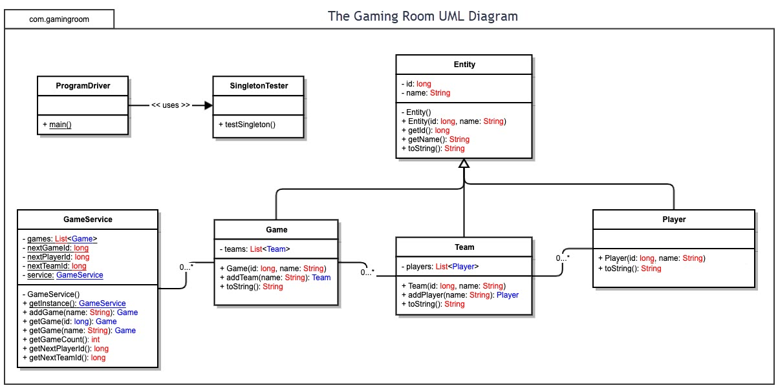

## Evaluation

Using your experience to evaluate the characteristics, advantages, and weaknesses of each operating platform (Linux, Mac, and Windows) as well as mobile devices, consider the requirements outlined below and articulate your findings for each. As you complete the table, keep in mind your client’s requirements and look at the situation holistically, as it all has to work together.

In each cell, remove the bracketed prompt and write your own paragraph response covering the indicated information.

* Does each of the operating platforms offer a server-based deployment method where the website will be hosted? Yes, each individual operating platform will offer a server-based deployment method.
* What are the potential licensing costs to the client, The Gaming Room, for the server operating system? Well, for Linux, GNU GPL, the software distributed under these licenses may generally be freely used for any purpose without the need for royalties or licensing payments.
* Advantages, Characteristics, and weaknesses. Windows OS does so much. With all of the windows OS capabilities, the security will automatically be increased. Therefore, the windows OS will offer more security. Windows is probably more expensive because of the added capabilities.

Determine the software development consideration (cost, time expertise) that are necessary for supporting multiple types of clients.

* What is required of the application development process to ensure the application is compatible with all web browser platforms and mobile devices? You have to have a really good api and a really solid server. Windows, Mac, Linux all are based on deferent programming languages and the API needs to be really robust for the language translation between platforms. Also, you have to take into consideration what IDE is being used to execute those languages. Also, think about the mobile apps. How will android integrate? The apps will have to be accessible by all three. This is where REST and JSON will significantly be the most beneficial.

**identify the relevant programming languages and tools (IDEs and other tools) that are used to build this type of software for deploying on each operating platform.** Consider the following and articulate your findings in the software design template:

* What impact do these technical requirements have on a development team? Consider whether multiple development teams may be needed.
  + You will have to have multiple developers, but you don’t want to have to many. You want to limit as many bodies as you can. This goes back to scrum methodologies. You want to keep communication open with the developers involved. The languages used for Windows is Visual Basic, and that IDE is Studio I believe. On the mac, You looking at a language focused in OC(objective c), and the IDE is xcode. Linux, used IDE eclipse, which is the ide that I am the most familiar with. The language is C.
* Are there licensing costs related to the development tools?
  + No. But it also depends on what you are trying to do.

| **Development Requirements** | **Mac** | **Linux** | **Windows** | **Mobile Devices** |
| --- | --- | --- | --- | --- |
| **Server Side** | <Evaluate Mac for its characteristics, advantages, and weaknesses for hosting a web-based software application.> | <Evaluate Linux for its characteristics, advantages, and weaknesses for hosting a web-based software application.> | <Evaluate Windows for its characteristics, advantages, and weaknesses for hosting a web-based software application.> | <Evaluate Mobile Devices for their characteristics, advantages, and weaknesses for hosting a web-based software application.> |
| **Client Side** | <Determine the software development considerations (cost, time, expertise) that are necessary for supporting multiple types of clients as they pertain to Mac.> | <Determine the software development considerations (cost, time, expertise) that are necessary for supporting multiple types of clients as they pertain to Linux.> | <Determine the software development considerations (cost, time, expertise) that are necessary for supporting multiple types of clients as they pertain to Windows.> | <Determine the software development considerations (cost, time, expertise) that are necessary for supporting multiple types of clients as they pertain to Mobile Devices.> |
| **Development Tools** | <Identify the relevant programming languages and tools (IDEs and other tools) that are used to build this type of software for deploying on Mac.> | <Identify the relevant programming languages and tools (IDEs and other tools) that are used to build this type of software for deploying on Linux.> | <Identify the relevant programming languages and tools (IDEs and other tools) that are used to build this type of software for deploying on Windows.> | <Identify the relevant programming languages and tools (IDEs and other tools) that are used to build this type of software for deploying on Mobile Devices.> |

## Recommendations

Analyze the characteristics of and techniques specific to various systems architectures and make a recommendation to The Gaming Room. Specifically, address the following:

1. **Operating Platform**: <Recommend an appropriate operating platform that will allow The Gaming Room to expand Draw It or Lose It to other computing environments.>

Ok, the current well known operating platforms Windows, macOS, and Linux are all fairly decent operating platforms. I would recommend the Windows operating platform. Windows is the most commonly used OS. It allows continuous patches, and is somewhat affordable. Everyone is familiar with the windows OS as well, so it would not be to hard to address any common issues that may arise with this OS.

1. **Operating Systems Architectures**: <Describe the details of the chosen operating platform architectures.>Windows allows adaptation to any windows-based software. You have accessibility to the internet, file and data storage. Windows utilizes icons for easy application selection. Windows OS supports Microsoft office, which is the most common form of communication used to communicate within and outside most corporations and smaller companies today.
2. **Storage Management**: <Identify an appropriate storage management system to be used with the recommended operating platform.> With The windows OS, you can create folders for important files, or just documents that you want to save. You can select any folder, or create any folder for a storage location within the windows OS. Because of the file management, I I would highly recommend the windows OS for this reason alone.
3. **Memory Management**: <Explain how the recommended operating platform uses memory management techniques for the Draw It or Lose It software.> The windows OS also allows you to store big files, such as pictures. Similarly, storage management and memory management go hand and hand. For huge projects that require lots of available memory, the windows OS is second to none.
4. **Distributed Systems and Networks**: <Knowing that the client would like Draw It or Lose It to communicate between various platforms, explain how this may be accomplished with distributed software and the network that connects the devices. Consider the dependencies between the components within the distributed systems and networks (connectivity, outages, and so on).> Wine is a free and open-source compatibility layer that aims to allow application software and computer games developed for Microsoft Windows to run on multiple OSs. Since you would like Draw it or Lose It to be communicated between different platforms, I would suggest utilizing the Wine software. The server should be able to handle the Wine software without hopefully any issues. There should be direct and straight forward communication from the end user to the server with all of the updates available through windows and the Wine continuous updates. There are other cross functional software that are available in the market if you feel that Wine is not suitable for your vision.
5. **Security**: <Security is a must-have for the client. Explain how to protect user information on and between various platforms. Consider the user protection and security capabilities of the recommended operating platform.> All of Windows OS has a built in security system. It constantly and consistently updates the windows OS system to address possible threats, such as viruses, malware, etc. You can also purchase outside protection as well if you feel that the protection provided with the windows OS is not sufficient. I would definitely recommend the windows OS if you are looking for optimal security. . .